2200030216 TASK7 Exercise 2: Verifying Interactions  
OUT PUT

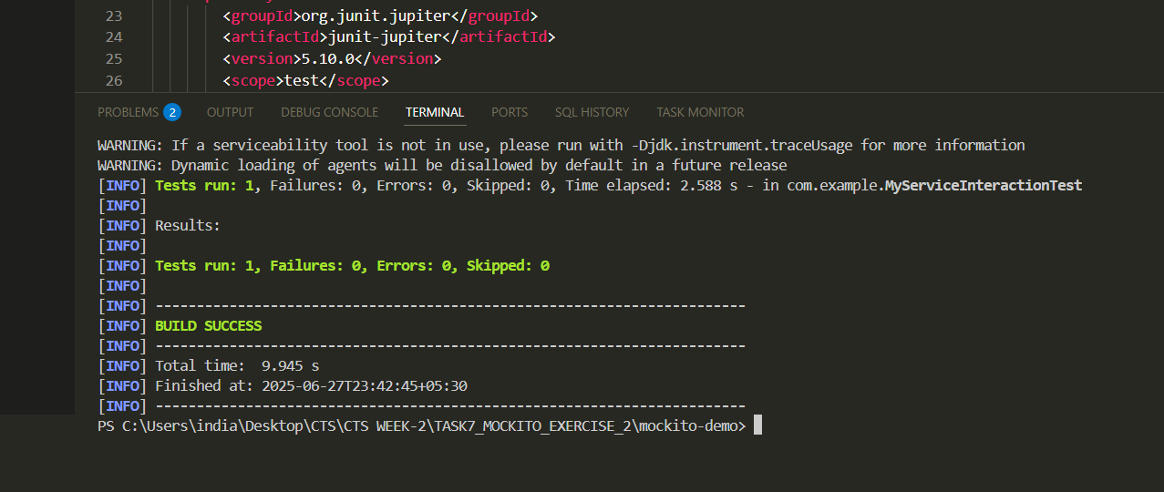

FILE  
